**Database Schema (Classic models)**

The MySQL sample database schema consists of the following tables:

* **Customers**: stores customer`s data.
* **Customer suggestion**: stores all the suggestions by customer such as new products on demand
* **Products**: stores a list of scale models heavy machinery.
* **Product Lines**: stores a list of product line categories.
* **Order**: stores sales orders placed by customers.
* **Payments**: stores payments made by customers based on their accounts.
* **Employee**: stores all employee information as well as the organisation structure such as line of authority.
* **Offices**: Store sales office data.
* **Warehouse**: Stores the locations that stock is stored
* **Management**: store the top management details.
* **New products**: stores details of new products in the pipeline.

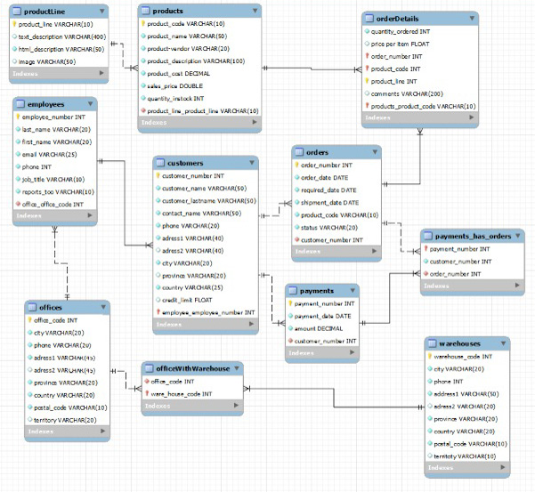

|  |  |  |  |  |
| --- | --- | --- | --- | --- |
| Table Name | Columns | DATA Type & Size | Null | Keys |

|  |  |  |  |  |
| --- | --- | --- | --- | --- |
| Customers | customer_number | int | NO | PRI |
|  | customer_name | VARCHAR (50) | NO |  |
|  | customer_last_name | VARCHAR (50) | NO |  |
|  | contact_first_name | VARCHAR (50) | NO |  |
|  | phone | VARCHAR (20) | NO |  |
|  | adress1 | VARCHAR (40) | NO |  |
|  | adress2 | VARCHAR (40) | YES |  |
|  | city | VARCHAR (20) | NO |  |
|  | province | VARCHAR (20) | YES |  |
|  | country | VARCHAR (25) | NO |  |
|  | credit_limit | DECIMAL (10) | NO |  |
|  | employee_number | Int | YES | MUL |

|  |  |  |  |  |
| --- | --- | --- | --- | --- |
| Products | product_code | VARCHAR (10) | NO | PRIMARY |
|  | product_name | VARCHAR (50) | NO |  |
|  | product_line | VARCHAR (10) | NO | MUL |
|  | product_vendor | VARCHAR (20) | NO |  |
|  | product_description | VARCHAR (100) | NO |  |
|  | product_cost | DECIMAL (10.0) | NO |  |
|  | sales_price | DECIMAL (10.0) | NO |  |
|  | quantity_in_stock | int | NO |  |

|  |  |  |  |  |
| --- | --- | --- | --- | --- |
| ProductLine | product_line | VARCHAR (10) | NO | PRIMARY |
|  | text_description | VARCHAR (400) | YES |  |
|  | html_description | VARCHAR (50) | NO |  |
|  | image | VARCHAR (50) | YES |  |

|  |  |  |  |  |
| --- | --- | --- | --- | --- |
| Orders | order_number | Int | NO | PRIMARY |
|  | order_date | date | NO |  |
|  | required_date | date | NO |  |
|  | shipment_date | date | NO |  |
|  | product_code | VARCHAR (10) | NO |  |
|  | status | VARCHAR (20) | NO |  |
|  | customer_number | int | NO | MUL |

|  |  |  |  |  |
| --- | --- | --- | --- | --- |
| OrdersDetails | order_number | Int | NO | PRIMARY |
|  | product_code | VARCHAR (10) | NO | MUL |
|  | quantity_ordered | int | NO |  |
|  | price_per_item | DECIMAL (10.0) | NO |  |
|  | product_line | VARCHAR (10) | NO |  |
|  | comments | VARCHAR (200) | YES |  |

|  |  |  |  |  |
| --- | --- | --- | --- | --- |
| PaymentsHasOrder | payment_number | Int | NO | PRIMARY |
|  | customer_number | int | NO |  |
|  | order_number | int | NO | MUL |

|  |  |  |  |  |
| --- | --- | --- | --- | --- |
| Payments | payment_number | Int (11) | NO | PRIMARY |
|  | Payment_date | date | NO |  |
|  | amount | DECIMAL (15.0) | NO |  |
|  | customer_number | int | NO | MUL |

|  |  |  |  |  |
| --- | --- | --- | --- | --- |
| Employee | employee_number | Int | NO | PRIMARY |
|  | last_name | VARCHAR (20) | NO |  |
|  | first_name | VARCHAR (20) | NO |  |
|  | email | VARCHAR (45) | NO |  |
|  | phone | VARCHAR (20) | NO |  |
|  | office_code | Int | NO | MUL |
|  | job_title | VARCHAR (10) | NO |  |
|  | reports_too | VARCHAR (10) | NO |  |

|  |  |  |  |  |
| --- | --- | --- | --- | --- |
| Office | office_code | Int | NO | PRIMARY |
|  | city | VARCHAR (20) | NO |  |
|  | phone | VARCHAR (20) | NO |  |
|  | address 1 | VARCHAR (45) | NO |  |
|  | address 2 | VARCHAR (45) | YES |  |
|  | province | VARCHAR (20) | NO |  |
|  | country | VARCHAR (30) | NO |  |
|  | postal_code | VARCHAR (10) | NO |  |
|  | territory | VARCHAR (20) | YES |  |

|  |  |  |  |  |
| --- | --- | --- | --- | --- |
| Warehouses | ware_house_code | Int | NO | PRIMARY |
|  | city | VARCHAR (20) | NO |  |
|  | phone | VARCHAR (20) | NO |  |
|  | address 1 | VARCHAR (45) | NO |  |
|  | address 2 | VARCHAR (45) | YES |  |
|  | province | VARCHAR (20) | NO |  |
|  | country | VARCHAR (30) | NO |  |
|  | postal_code | VARCHAR (10) | NO |  |
|  | territy | VARCHAR (20) | YES |  |

|  |  |  |  |  |
| --- | --- | --- | --- | --- |
| officesWarehouses | Ware_house_code | Int | NO | PRIMARY |
|  | Office-code | int | NO |  |

**TEST CASES**

* Check table presence in database schema.
* Check table name conventions.
* Check number of columns in a table
* Check column names in a table
* Check data type of columns in table.
* Check size of the columns in a table.
* Check null fields in a table.
* Check column key in a table